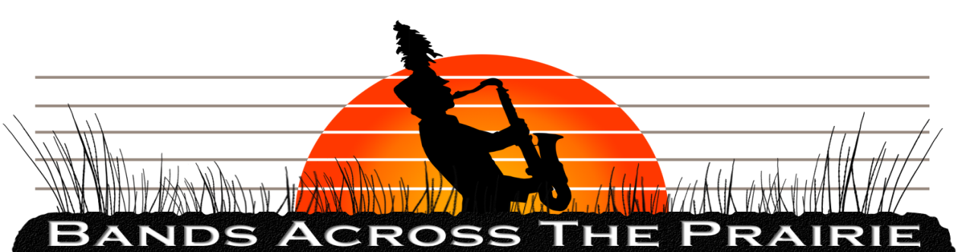

The ultimate in innovation for marching band performance, education and entertainment!

Categories of Adjudication

Music – General Effect: (300 Points)
Adjudicated from up in the Press Box, this caption considers the overall effect and impact of the performance from a musical standpoint. Three main areas of concern on the judge’s ballot include musical content, performance effectiveness, and coordination of the music to the visual elements of the show.

Music – Execution: (200 Points)
Adjudicated down on the field, this caption considers the musical performance on an individual level. Within the three main areas of brass, woodwinds, and percussion, the judge’s ballot considers accuracy of notes and rhythms, phrasing, precision, and the overall level of difficulty of what is being performed.

Marching & Maneuvering – General Effect: (300 Points)
Adjudicated from up in the Press Box, this caption considers the overall effect and impact of the performance from a visual standpoint. Four main areas of concern on the judge’s ballot include visual repertoire, showmanship, definition of patterns, and use of auxiliary personnel and equipment.

Marching & Maneuvering – Execution: (200 Points)
Adjudicated down on the field, this caption considers the level of uniformity within the band during the performance. Four main areas of concern on the judge’s ballot include accuracy and definition, exposure to error, poise, and the technique utilized by the auxiliary personnel.

Percussion: (100 Points…this score is not included in the Total Score for each band, since other ballots already contain points for the Percussion category)
Adjudicated down on the field, this caption examines both the Battery (marching percussion members) and the Front Ensemble (grounded “pit” percussion members). Ballot considerations include level of demand, exposure to difficulty, individual and ensemble technique, and a overall musicianship.

Color Guard: (100 Points…this score is not included in the Total Score for each band, since other ballots already contain points for the Color Guard category)
Adjudicated from up in the Press Box, this caption considers the overall effectiveness of the auxiliary members of the ensemble, both in terms of individual performance as well as in relationship to the entire band’s performance. Three main areas of concern on the judge’s ballot include level of artistry, level of achievement, and the utilization of time and space.

Clinicians:
Although their final scores are not included in the total given for each band’s performance, the Clinicians are providing one of the most unique and valuable educational opportunities ever presented to area high school marching band members. Immediately after viewing a band’s performance from the Press Box, the Clinician is transported to either the Concert Hall or the Auditorium of Prairie High School, where they await the arrival of the band that just finished performing! Then, in the air-conditioned comfort of our state-of-the-art facilities, the Clinician reviews the performance with the band via large-screen video projection, connected to a wireless sound system and equipped with a laser pointer! Students and directors now receive immediate feedback regarding the strengths of their performance, as well as areas that may require improvement. Members of each band performing in the “Bands Across the Prairie” Marching Invitational no longer have to wait until the next rehearsal on Monday to see and hear how they performed tonight…they can see and hear it immediately, and through the experienced eyes and ears of our talented Clinicians!

